**Problem 01**

Write a program that accepts user’s section and display them back with the format “*** Section: user’s section ***”.

**Solution and Testing 01**

We shall use cin to accept the user’s section and cout to display. We shall assume sections are numeric and we will use the short integer data type to conserve memory, since “school” sections normally would be less than 100, anyway.

Below is the screenshot of solution program as well as testing in the terminal.

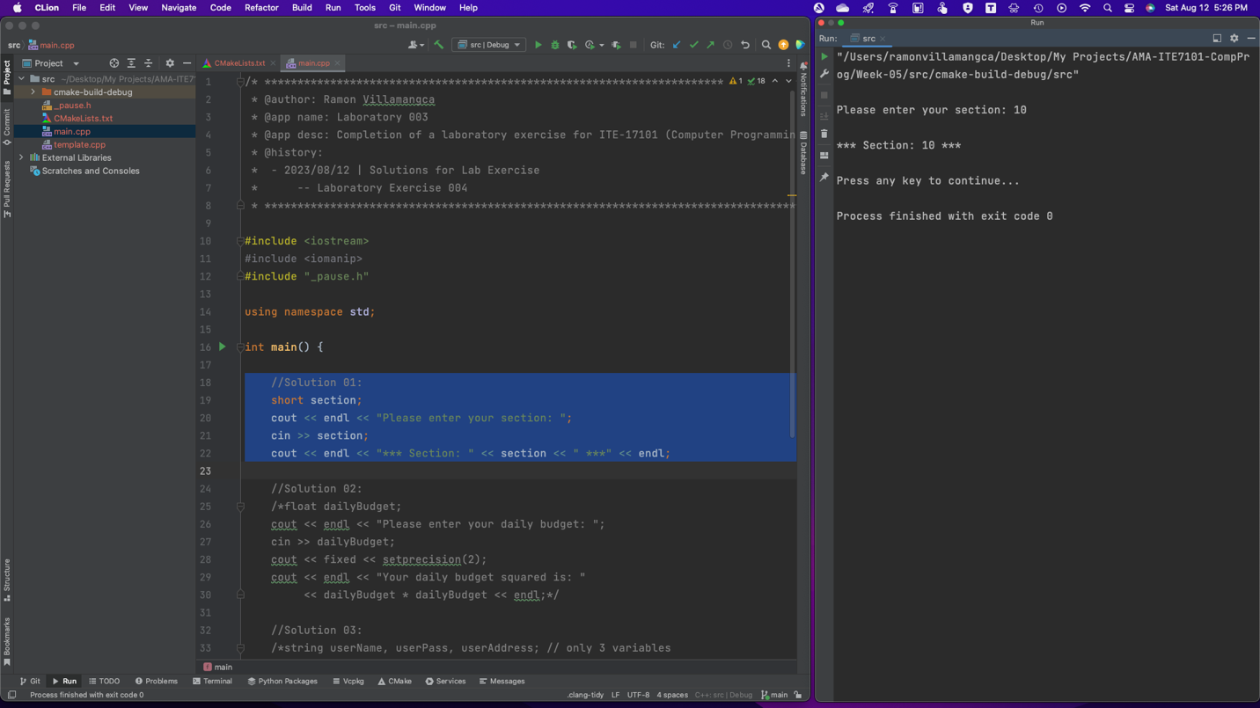

**Problem 02**

Write a program that accepts user’s daily budget and display the product of the daily budget and itself.

**Solution and Testing 02**

We shall use cin to accept the user’s daily budget and cout to display the product of the daily budget by itself. We shall assume sections are numeric and we will use the float as the data type. Because this is currency, we shall also force cout to output only 2 decimal places, by including <iomanip> STD libary.

Below is the screenshot of solution program as well as testing in the terminal.

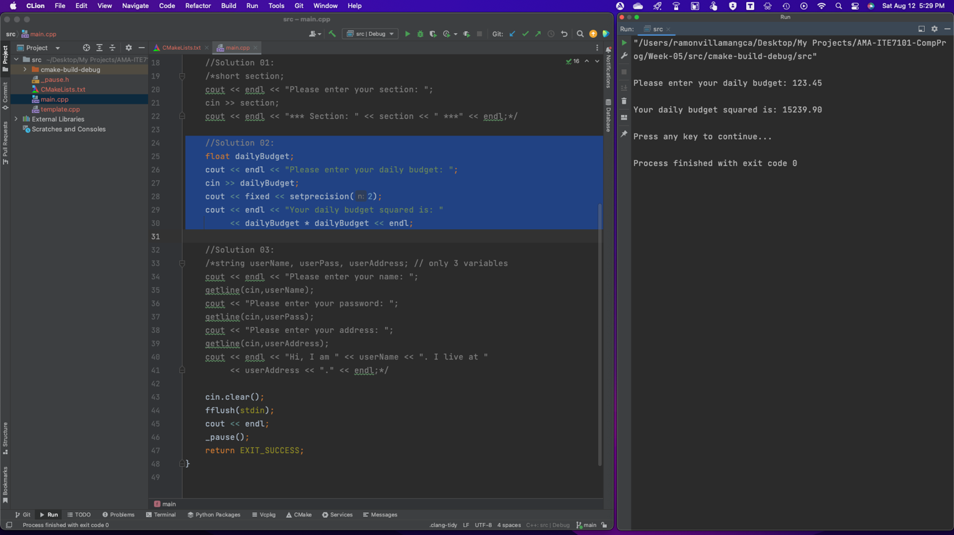

**Problem 03**

Write a program that accepts user’s name, password and address and display them back using the format “Hi, I am user’s name. I live at user’s address.”.

Restrictions:

* Use only three variables.
* Make sure you support spaces.

**Solution and Testing 03**

To force input of including spaces, we shall use getline(cin)to accept the user’s name, password and address, We then use cout to display the output.

Below is the screenshot of solution program as well as testing in the terminal.

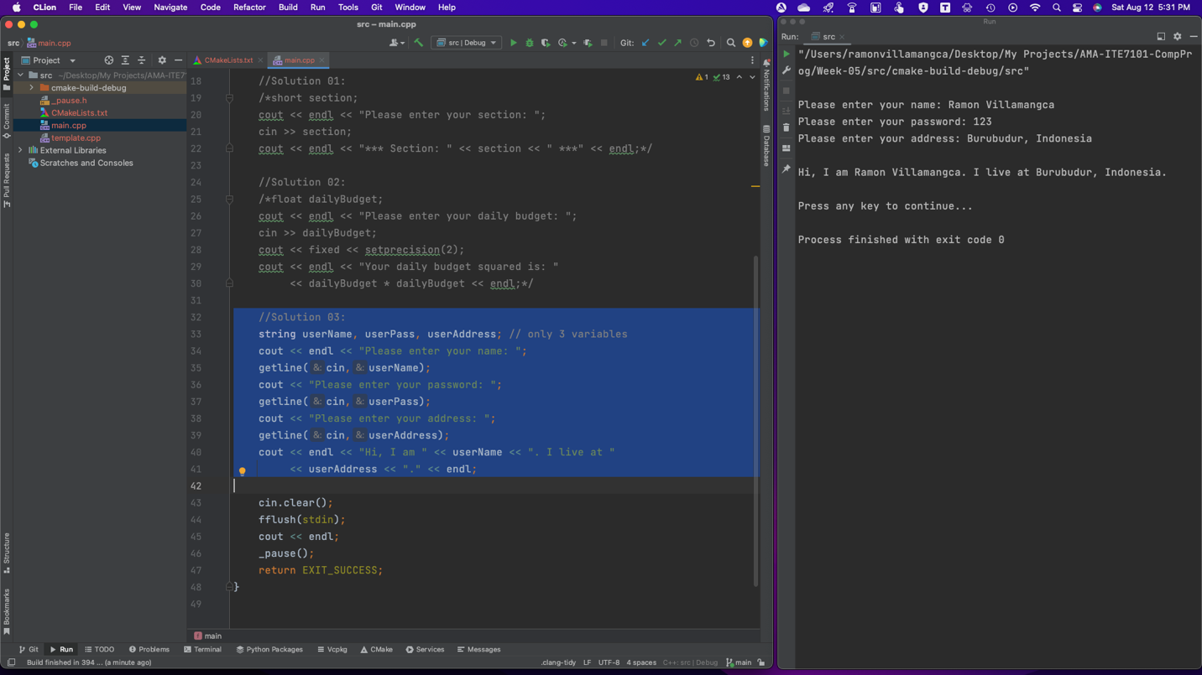

**Problem 04**

What can you conclude from this activity?

**Answer 04**

The answers I presented may not be the same as what problem creator has in mind. However, the solutions do work! There are many ways to attack the same programming problem.

------------------------

**NOTE FOR THIS PROBLEM:**

Source code can be found on my GitHub page: <https://github.com/rvillamangca/>.

